1

Table of Contents

• Chapter 1: Accounting in Action

• Chapter 2: The Recording Process

• Chapter 3: Adjusting the Accounts

• Chapter 4: Completing the Accounting Cycle

• Chapter 5: Accounting for Merchandising Operations • Chapter 6: Inventories

• Chapter 8: Recognition of Accounts Receivable

2

Chapter 1: Accounting in Action

3

What is Accounting? (boring version)

• Recognizing, recording, communicating economic activities • Interested users:

• Internal (management)

• External (shareholders)

• Different types:

• Cost accounting

• Audit

• Tax

• Deliver financial info to concerned users

4

What is Accounting? (better version)

• Language of financial information

• Words in a sentences = numbers in financials

• Wealth lies in financial literacy

• Reading numbers to get ahead

• Don’t believe me… Warren Buffet

5

Warran Buffet on Accounting

• https://www.youtube.com/watch?v=rV3Etfww7EQ&ab_channel=Inve stmentKnowledge

6

Financial vs Managerial Accounting

**Financial Accounting**

• Collecting data for financial statements

• Emphasis on past • External users

• Follow GAAP/IFRS

**Managerial Accounting**

• Collecting data for

business decision-making

• Emphasis on future

• Internal users

• Follow logic

7

Assets

• Economic resources controlled by the company

• Result from past business events

• Expected future economic benefits

• Recorded at **historical cost**

• The cost of acquisition

• Examples:

• Accounts receivable

• Inventory

• PPE

• Cash

8

Liabilities

• Debts/firm obligations

• Result from past business events

• Expected future outflow of economic resources

• Examples

• Accounts payable

• Unearned revenue

• Notes payable

• Principal & interest payments

9

Shareholders’ Equity

**Contributed capital**

• Permanent Investments for equity

• Common stock

• # & total value of shares issued

**Retained Earnings**

• Consists of revenues, less expenses and dividends

**Other**

• Changes in values of

assets/liabilities

10

The Accounting Equation

**Assets = Liabilities + Shareholders’ Equity**

• Must always remain balanced

• Only 2 ways to acquire assets

Ex. 1) If Nike has $900K in assets and $300K in liabilities, what is the balance in SE?

11

12

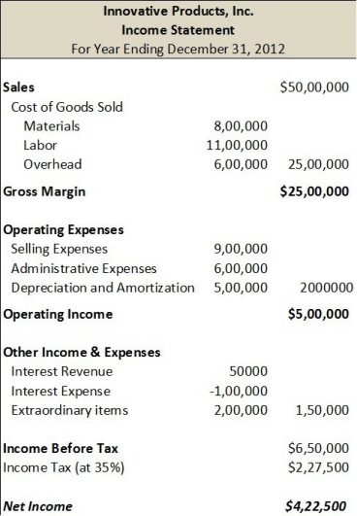13

14

15

Generally Accepted Accounting Principles (GAAP)

• Universal set of accounting regulations

• In Canada:

• Public companies follow International Financial Reporting Standards (IFRS) • Private companies can follow IFRS or ASPE

• In USA:

• Comply with US GAAP

• Regulated by the SEC

16

Chapter 2: The Recording Process

17

Accounting Equation – Expanded

• Assets = liabilities + SE

• SE = common stock + retained earnings (RE)

• RE = net income – dividends

• RE = revenues – expenses – dividends

• Assets = liabilities + common stock + revenues – expenses - dividends 18

Transaction Analysis

• 1) Identify accounts involved

• 2) Determine direction of effect

• 3) Check that A = L + SE remains balanced

• Duality of effects

• Every transaction affects min. 2 accounts

19

Transaction Analysis – Examples

• 2) Nike issues $4,000 of common shares to investors for cash. • 3) Nike borrows $12,000 from the bank with a 5-year note.

• 4) Nike buys $8,000 in new equipment for making shoes. They pay $1,000 in cash, and agree to a 3-year note for the balance.

20

Journal Entries

• Method for analyzing transactions

• Recording as either “Debit” or ”Credit”

• ONLY signal left and right

• Summarize results of economic transactions

21

Journal Entries – Examples

• 5) Nike issues $4,000 of common shares to investors for cash. • 6) Nike borrows $12,000 from the bank with a 5-year note.

• 7) Nike buys $8,000 in new equipment for making shoes. They pay $1,000 in cash, and agree to a 3-year note for the balance.

22

General Ledger

• Shows effects of multiple economic transactions

• Isolates balances for each individual account

23

General Ledger – Examples

• 8) Nike issues $4,000 of common shares to investors for cash. • Nike borrows $12,000 from the bank with a 5-year note.

• Nike buys $8,000 in new equipment for making shoes. They pay $1,000 in cash, and agree to a 3-year note for the balance.

24

Debit and Credit Framework

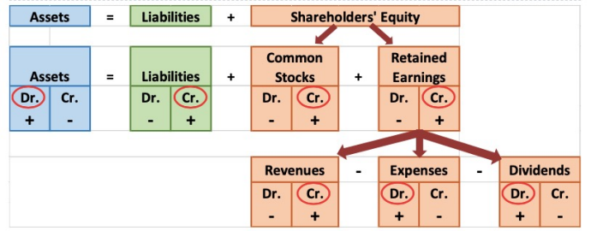• Gain = economic benefit outside regular operations

• Loss = economic loss outside regular operations

25

Debits and Credits for Journal Entries

• **D.E.A.D**

• Debit expenses, assets, dividend increases

• Credit all other increases

• Debits = Credits ALWAYS

26

Trial Balance 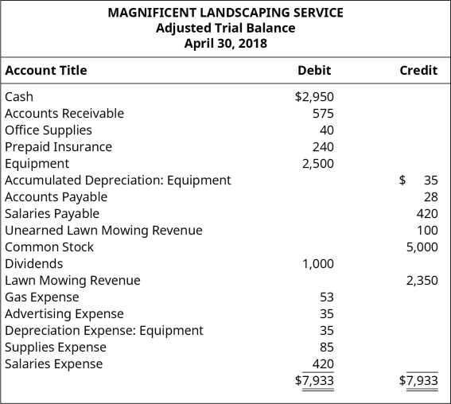

27

Chapter 2 Summary

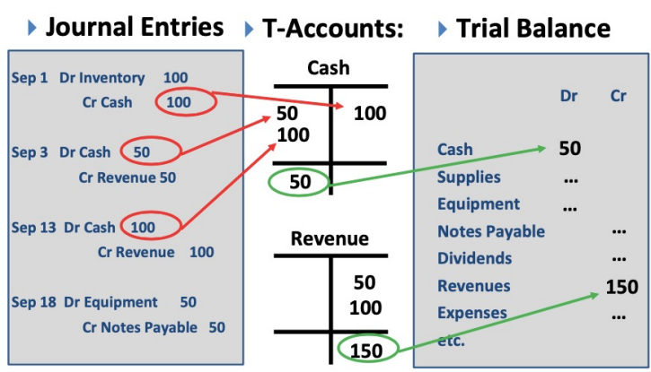28

Chapter 3: Adjusting the Accounts

29

Accounts Receivable vs Accounts Payable

**AR**

• Records amounts for

goods/services given on credit • Money owed TO company • Asset

**AP**

• Records amounts for

goods/services received on credit

• Money owed BY company • Liability

30

Methods of Measuring Income

**Cash Basis**

• Revenues/expenses recorded at transfer of cash

• Not used often, not GAAP

• Can be manipulated by management

**Accrual Basis**

• Revenues/expenses recorded as incurred

• Used most often, follows GAAP

• Independent of cash receipts timing

31

Revenue Recognition Principle – Examples

• 1) Cash received BEFORE revenue is earned

• Dr Cash

• Cr Unearned revenue (liability)

• 2) Cash received WHEN revenue is earned

• Dr Cash

• Cr Sales revenue (retained earnings)

• 3) Cash received AFTER revenue is earned

• Dr Accounts receivable

• Cr Sales revenue

32

Revenue Recognition Principle

• Revenues to be recorded when earned

• Independent of when cash is received/paid

• 9) Ex: Nike sold $2,000 worth of merchandise on Jan 3rd , but cash payment was collected on Jan 22. When is revenue recognized? Journal entries:

33

Expense Recognition Principle – Examples

• 1) Cash paid BEFORE expense is incurred

• Dr Prepaid expense (asset)

• Cr Cash

• 2) Cash paid WHEN expense is incurred

• Dr Expense

• Cr Cash

• 3) Cash paid AFTER expense is incurred

• Dr Expense

• Cr Expense payable

34

Expense Recognition Principle

• Expenses to be recorded when earned

• Independent of when cash is received/paid

• 10) Ex: Nike’s marketing team received a $500 commission for the sale of merchandise on Jan 3rd , but it was paid out on Jan 20. When is the expense recognized? Journal entries:

35

Two Kinds of Adjusting Entries

**Deferrals**

• Receipt of assets/cash BEFORE incurring

revenue/expense

• Ex. prepaid expenses, unearned revenues

**Accruals**

• Receipt of assets/cash AFTER incurring revenue/expense

• Ex. accrued

revenues/expenses

36

Deferrals Example

11) Mike spent $700 on Jan 1st to cover the month’s rent fee. What are the journal entries on Jan 1st and Jan 31st?

37

Accruals Example

• 12) Mike decided to open a car wash. On Jan 3, Bill came and received a $30 car wash on credit. Next week on Jan 7, Bill sent an e-transfer to cover the cost of the car wash. What are the Jan 3 and Jan 7 journal entries for Mike and Bill?

38

Depreciation

• Method for allocating cost of tangible asset

• Journal entry: Dr Depreciation Expense, Cr Accumulated Depreciation • Depreciation expense for current (single) period

• Accumulated depreciation -> contra-asset account

• Accounts for multiple periods of depreciation

• Depreciation expense = depreciable amount / useful life • Depreciable amount = (cost of acquiring – residual value) / useful life

39

Accumulated Depreciation vs Depreciation Expense

**Accumulated Depreciation** • Credit balance

• Contra-asset account, offsets assets on balance sheet • Permanent account

**Depreciation Expense**

• Asset depreciation for 1

period

• Appears on income statement • Temporary account

40

Adjusting Entries – Depreciation

• 13) Nike bought a company truck for $98K on Jan 1, 2019. The truck has a useful life of 7 years and is expected to generate annual sales of $300K with no residual value. Jan 1, 2016 journal entries:

• Adjusting entries on Dec 31, 2016 for depreciation:

41

Book Value

• Book value = cost of depreciable asset – accumulated depreciation

• 14) Ex. Nike bought a company truck for $98K on Jan 1, 2019. The truck has a useful life of 7 years and is expected to generate annual sales of $300K with no residual value. Book value at Dec 31, 2021?

42

Expenses Misstatement - Example

• Payments cover beyond current period

• 15) Ex. A business paid $100,000 in salaries for 2 years at the start of their fiscal year. They recorded this journal entry:

• Dr Salaries Expense $100,000

• Cr Cash $100,000

• Adjusting journal entry at year end:

43

Chapter 4: Completing the Accounting Cycle 44

Purpose of Closing Process

• Balance sheet items roll-forward balances

• I/S items don’t roll forward balances

• Must create 0 balance in temporary accounts

• Allocate net income/loss to retained earnings

45

Permanent vs Temporary Accounts

**Permanent Accounts** • Assets

• Liabilities

• Shareholders’ Equity

**Temporary Accounts**

• Revenues

• Expenses

• Gains

• Losses

• Dividends declared

46

Step 1) Closing Revenues to Income Summary

• 16) Ex. Nike has balances of $7,000 in sales revenue, $3,000 in service revenue and $500 gain from investments.

47

Step 2) Closing Expenses to Income Summary

• 17) Ex. Nike has balances of $2,000 in COGS, $1,500 in advertising, $1,000 in office supplies, and $500 in legal fees.

48

Step 3) Close Income Summary to Retained Earnings

• 18) Income Summary has a balance of $5,500

49

Step 4) Close Dividends to Retained Earnings • 19) Ex. Nike has a dividend balance of $100

50

Skipping Income Summary

**Closing revenues:**

• Dr Revenues/Gains

• Cr Retained Earnings

**Closing expenses:**

• Dr Retained Earnings

• Cr Expenses/Losses

**Closing dividends:**

• Dr Retained Earnings

• Cr Dividends

51

Balance Sheet Classifications

• Current assets

• Expected usage within 1 year

• Long-term investments

• PPE

• Intangible assets

• Current liabilities

• Obligations due within 1 year

• Obligations paid after 1 year

• Accounts ordered by liquidity

52

Operating Cycle

• Time period for inventory to turn to cash

• 1) Purchase inventory

• 2) Sell it on account

• 3) Collect payment from customers

• Approximately 1 year

53

Chapter 5: Accounting for Merchandising Operations

54

Merchandising Companies

• Product/goods oriented rather than services

• Retailers (sales direct to end-users)

• Ex. Walmart, Superstore

• Wholesalers (sales to retailers)

• Ex. Proctor & Gamble, General Mills

• Hold inventory as current asset

• COGS is total cost of goods (inventory) sold

55

Perpetual vs Periodic Inventory Systems

**Perpetual**

• Constant tracking of inventory changes

• Better control over inventory • Real time reporting of profits • Expensive to maintain

• Common for high-value goods

**Periodic**

• Does not keep constant track of inventory changes

• COGS calculated only at the end

• Not always up to date

• Inventory adjusted end of period

56

Cost of Goods Sold (COGS)

• Direct cost of goods acquired that were sold

• Cost incurred only if inventory is sold

• Essential in matching principle

57

Perpetual Inventory – Delivery Costs

• If seller pays for delivery of inventory:

• Dr Delivery Expense

• Cr Cash/AP

• No journal entries for buyer

• If buyer pays for delivery of inventory:

• Dr Inventory

• Cr Cash/AP

• Included in overall cost of inventory

58

Perpetual Inventory – Delivery Costs Example

• 20) Nike buys $5,000 worth of clothes from XYZ on Jan 3 and pays $500 delivery costs on credit. The journal entries for Nike:

• 21) If XYZ (the seller) takes care of the delivery costs, the journal entries for Nike and for XYZ are:

59

Perpetual Inventory – Purchase Discounts

• Discount granted on sale of inventory

• Journal entries

• Dr AP

• Cr Inventory

• Cr Cash

60

Perpetual Inventory – Purchase Allowance

• Reduction in price due to item defect/wrong order

• Journal entries

• Dr AP

• Cr Inventory

61

Perpetual Inventory – Purchase Return

• Customer returns item to merchandiser

• Journal entries

• Dr AP

• Cr Inventory

62

Credit Terms

• Ex. Nike bought $10,000 worth of clothes from XYZ on account with credit term 3/12, n/30

• Three-twelve, net thirty

• 3 % discount if paid within 12 days, else full balance in 30 days 63

Credit Terms – Example

• 22) Ex. Nike bought $40K clothes on account from XYZ on Feb 2 with credit terms 3/12 , n/30.

• Feb 2 journal entries for Nike:

• Assuming Nike pays on Feb 13, journal entries:

• Assuming Nike pays on Mar 1, journal entries:

64

Perpetual Inventory – COGS Example

• 23) Nike sold $7,000 clothes on credit to customers on Jan 14. The clothes cost Nike $2,500 at the time of the transaction. Journaling the credit sale for Nike:

• Journaling the COGS for Nike:

65

Perpetual Inventory – Purchase Returns Ex.

• 24) Nike bought too many clothes from supplier XYZ and opted to return $4,000 cloths to XYZ on Jan 5. The clothes cost XYZ $1,000 to make. The journal entries for Nike:

• The journal entries for XYZ:

• Sales returns and allowances -> contra-revenue account for the seller 66

Sales Returns & Allowances – for Seller

• Sales return (customer returns product for refund)

• Dr Sales returns and allowances*

• Cr Accounts receivable

• Sales allowance (customer granted price reduction as compromise for incorrect order/broken product)

• Dr Sales returns and allowances*

• Cr Accounts receivable

• *Contra-revenue accounts

• Deducted from gross sales revenue to determine net sales

• Debit balance, increases lower revenues

67

Periodic Inventory – Journal Entries

• For purchasing inventory:

• Dr Purchases (expense account)

• Cr Cash/AP

• For selling goods

• Dr Cash/AR

• Cr Sales revenue

• For COGS

• No entry required

• Recall: COGS determined end of year in periodic system

• Beginning Inv + Net purchases = COGAS , COGAS – Ending Inv = COGS 68

Periodic Inventory – Purchase Discounts, Returns & Allowances

• For purchase discount: • Dr AP

• Cr Purchase discounts* • Cr Cash

• For purchase allowance: • Dr AP

• Cr Purchase allowances* • For purchase return: • Dr AP

• Cr Purchase returns*

• *Contra-expense accounts

• Deducted from gross

expenses

• Credit balance

69

Net sales reporting

• Sales revenue

• Less: Sales Discounts

• Sales returns & allowances

• Net Sales

• Less: COGS

• =Gross profit (gross margin)

70

Net income reporting

• Multi-step income statement

• = Gross profit

• Less: Operating expenses

• = Operating income before taxes

• Less: Taxes

• = Net Income

• Operating expenses are rent, supplies, salaries, advertising 71

Income Statement Equations

• Gross profit = Net sales – COGS

• Gross profit rate = Gross profit / Net sales

• Single-step I/S:

• Net income = Revenues – Expenses

• Multi-step I/S:

• Net income = Gross profit – Operating expenses

• Net income = Net sales – COGS – Operating expenses

72

Gross Profit Rate vs Markup

**Gross profit rate**

• Based on net sales

• (Net sales – COGS) / Net sales

**Markup**

• Based on price

• (Sales price – cost) / cost * 100

25) Ex. Nike marks up a pair of shoes to sell for retail at $120 that cost $60 to make. Determine the markup and gross profit rate.

73

Chapter 6: Inventories

74

Cost of Sales

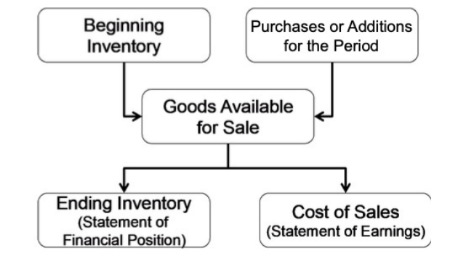75

Perpetual vs Periodic Inventory Systems 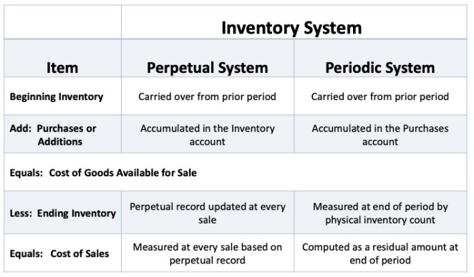76

Determining Ownership of Goods

• FOB shipping point

• Possession passes to buyer when goods are shipped

• Buyer pays transport costs

• FOB destination

• Possession passes to buyer when goods are delivered

• Seller pays transport costs

• Consigned goods

• Inventory given to a 3rd party (consignor) to sell

• Still belongs to manufacturer/merchandiser

• Possession not transferred, no revenue recognition

77

Inventory Cost Flow Methods: Specific Identification

• Tracks specific costs to specific goods

• Common for special/unique goods

• COGS calculated specifically with goods sold in period • Inventory calculated based on specific items remaining • Expensive, needs detailed info

• Same results with perpetual & periodic inventory

78

Inventory Cost Flow Methods: First-In, First Out (FIFO) Assumptions

• Earliest goods bought are 1st to be sold

• 1st (oldest) goods are first to be recognized as COGS

• Oldest units not actually sold first (but their costs are recognized first) • Oldest costs -> COGS

• Newest costs -> Ending inventory

• Used in periodic inventory (not in perpetual)

79

FIFO Example

• 26) Walmart bought 600 milk cartons for sale at $0.3 each on Jan 2. Then, they bought 300 milk cartons at $0.4 each on Jan 5. Finally, they bought 100 milk cartons at $0.7 on Jan 10. All milk cartons are identical. On Jan 12, Walmart sold 500 milk cartons at $2 each. Determine COGS and ending inventory on Jan 12.

80